IKE 9 COLLEGE PREP CARES
This Photo by Unknown Author is licensed under CC BY-NC

SUN SAFETY WEEK March4-8th:
Remember to do the following things to help prevent Skin Cancer.
- Wear hats
- Wear protective clothing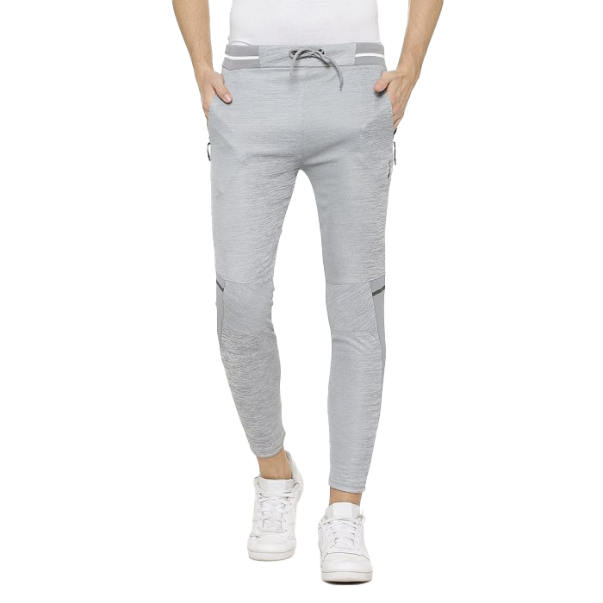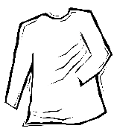
This Photo by Unknown Author is licensed under CC BY-NC
- Sunglasses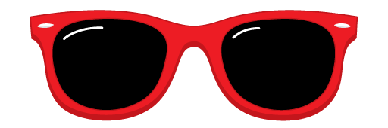
This Photo by Unknown Author is licensed under CC BY-NC
- Sun screen with SPF 30 or higher.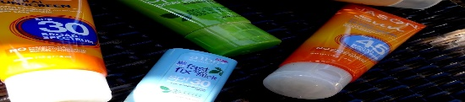
This Photo by Unknown Author is licensed under CC BY-NC-ND

